Chapter 8, Problem 48.

Given the circuit in Fig. 8.95, find i(t) and v(t) for t > 0.

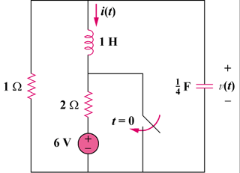

Figure 8.95
For Prob. 8.48.

